
Yr 10 Pathway 2
Mini Test 7
Parabolas

Name : ____________________ Total ___/28

Multiple Choice (chose just one answer)
- Which of the following equations is a parabola?
  - y = 2x + 4
  - y = 2x³ + 4
  - y = 2x² + 4
  - y = 2^{x}

- Which is the most basic equation of a parabola?
  - y = x²
  - y = 2x² + 3
  - y = -x² -4
  - y = -x²

- What happens to the parabola when you multiply its equation by a number bigger than 1?
  - Graph moves UP
  - Graph gets WIDER
  - Graph moves DOWN
  - Graph gets NARROWER

- When you add a number to y=x² what happens to the graph?
  - Graph moves UP
  - Graph moves to the RIGHT
  - Graph moves DOWN
  - Graph moves to the LEFT

- Which way does the graph move if the equation looks like y = (x - k)² ?
  - Graph moves UP
  - Graph moves to the RIGHT
  - Graph moves DOWN
  - Graph moves to the LEFT

Question 6-10 refer to the graph on the right
- What is the turning point of this graph?
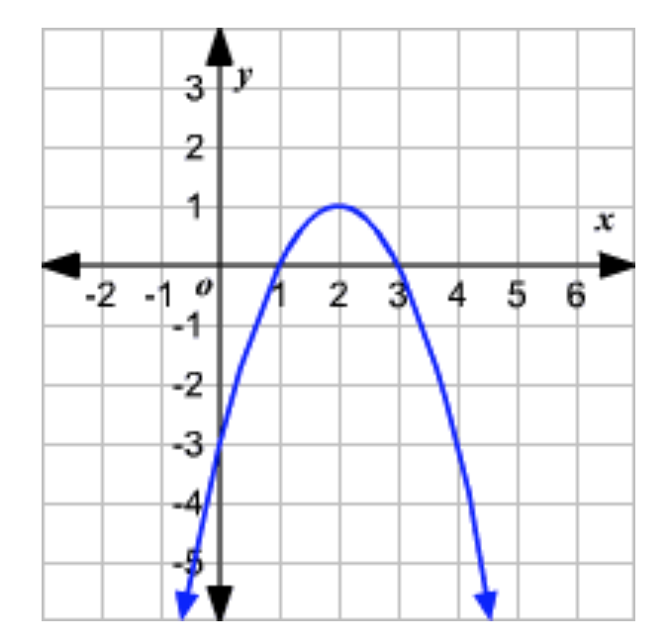
  - x=2
  - y=-3
  - (2, 1)
  - y=1

- What are the coordinates of the y-intercept?
  - (-3, 0)
  - (0, -3)
  - (2, 1)
  - y=-3

- What are the x-intercepts for this graph?
  - 1 and 3
  - 1 and -3
  - 0 and -3
  - 0 and 3

- Does this graph show a maximum or a minimum?
  - Maximum
  - Minimum

- What is the axis of symmetry for this graph?
  - y=2
  - x=2
  - x=0
  - y=0

- The coordinates of the x-intercept(s) of the graph of y = x2 + 3x – 10 are:
    - (2, 0) and (-5, 0)
    - (0, -10)
    - (5, 0) and (-2, 0)
    - (0, -5) and (0, -2)
    - (5, 0) and (2, 0)

Short Answer
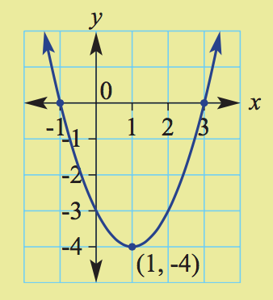
- 16. State the following features of the quadratic graph shown. (6 Marks)
- A Turning point and whether it is a maximum or a minimum (2)
- _______________________
- B Axis of symmetry (1)
- _______________________
- C x-intercepts (2)
- _______________________
- D y-intercept (1)
- _______________________
17.Consider the equation y = 2x2 - 8. (11 Marks)
- Set up a table of values with x-values from -3 to 3. (3)
- Plot the points on a coordinate plane and label the graph. (4)
- Find the turning point of the graph and label them. (1)
- Determine the x- and y-intercepts for the graph and label them. (3)
